**Department of Electrical and Computer Engineering**

**North South University**



**Senior Design Project**

Home Automation System using Zero-Crossing detectors and Thyristor based Power Converter integrated with the world-wide-web and an Android app.

**Noor Al Din Ahmed ID# 1310607043**

**Rahatul Aine ID # 1220812042**

**Faculty Advisor:**

**Tanzilur Rahman (Tnr)**

**EEE499A**

**Section: 05**

**Summer, 2017**

**499A Semester End Progress Report**

**Title:**

Home Automation System using Zero-Crossing detectors and Thyristor based Power Converter integrated with the world-wide-web and an Android app.

**Problem Description:**

Home Automation Systems (HAS) in today’s world are usually expensive or bulky. The main problem associated with most of the devices is the technology that is needed to implement when it is bulky and/or expensive.

If relays are used for the core switching functionality. They system would get bulky and the cost would increase. And problems associated with relay based switching is, a user cannot control the power that is given as input to the appliances, such as lights or fans or any inductive load.

So, a semiconductor based system is being used throughout the circuit to reduce the form factor and the price of the overall product. But the problems associated with it come with the complexity of using the right algorithm for the programming of the hardware. But that is a one-time process, if mastered, can open up a whole new area of controllability. So the first problem that needs to be solved is building a proper zero crossing detector (ZCD), then make a prototype for a thyristor based switching circuit to control the power output to the loads. And to make the two units talk to each other, an algorithm needs to be implemented to the systems main processing core, which in this project would be the Arduino Pro Mini.

Since the whole unit will be controlled through the web, a web server is needed along with a database and API functionality.

So our main goal for 499A is to make a Zero Crossing Detector, then a Thyristor based switching circuit and the code needed to process the signals towards the input of the load.

**Knowledge:**

1. **Hardware:**

Zero crossing is a term commonly used in electronics, mathematics, image processing and sound. It is the point in a sinusoidal wave, where the mathematical function transits from a positive cycle to a negative cycle, or vice versa. Zero-Crossing detector is a device that is used mainly for measuring the frequency, period, or phase difference of a periodic AC signal by detecting the time period between two or more zero crossing points.

There are many methods to detect zero crossing proposed by various authors. Some of them are:

* Zero crossing detection by interpolation – This uses two signals from a single source where one point is found just before the 0V of the main signal and the other point is found right after the 0V of the same signal. These two signals are then interpolated to converge towards a new point that is close to the 0V point. This method required computer processing.
* Comparator circuits with fixed hysteresis – This circuit takes the input of the main signal and compares the voltage with two reference voltages. One that is at zero and another that is close to zero. This prevents multiple zero crossing detection that occurs near the zero crossing point of the sinusoid.
* Comparator circuits with dynamic hysteresis. – This circuit works just like the fixed hysteresis circuit but has dynamic threshold voltages that further prevent multiple zero crossings. A capacitor is added at the feedback that adds to the positive feedback when the first zero crossing is detected. And then the feedback slowly decays overtime to dynamically change the threshold voltage.

This theory was learnt so that when a zero crossing is detected, the signal can be delayed at will, using a microcontroller to the input of a TRIAC gate. This will cause the TRIAC to switch on at a different phase of the AC source, hence controlling the output power towards the load.

1. **Software:**

XML – we gathered the basic concepts of xml and learnt its syntax. Learned about ‘XML HttpRequest object’ which is used to request and receive data from a web server. Learned the functions of XML HttpRequest object and how it can be implemented to interact with server.

Web development – Learning about HTML, CSS, JavaScript, jQuery through online tutorials and besides practicing some exercises on that.

Arduino web server – Following the tutorials which are about setting up an Arduino with Ethernet shield as a web server. These tutorials taught us about connecting and testing the Ethernet shield with arduino to the network; serving up a HTML web page through Arduino web server using the Arduino sketch; storing a webpage into a SD card and then fetching it from there using Arduino and switching an LED on and off through a webpage.

These concepts will be needed to set up the ESP8266 Wifi module later, as the codes are fairly similar. The working principal of the Ethernet shield was learnt first because there is more documentation available for the Ethernet then it is for the ESP8266.

**Tools:**

* Arduino IDE – Familiarizing with the software interface that is needed to program an arduino.
* Arduino Ethenet Sheild – A piece of hardware needed to connect the Arduino with the internet through an RJ45 cable. Used it to get familiarized with the Arduino web development environment.
* MultiSim – To simulate the circuits that is need for this project. So far, the simulation and the results for the ZCD were fruitful using this simulation tool.
* Django Web Framework – A python based web development module that is typically used to create web apps.
* Django REST framework – A Django extension that is used to create an API with ease.
* Matlab – A mathematical tool to plot the data that is being received from the Arduino.

**Hardware/Software developed:**

A zero-crossing detector was built using the following components:

* 2 x 220K(ohms) resistor
* 1 x 22K(ohms) resistor
* 2 x 1K(ohms) resistor
* 1 x 10uF capacitor
* 1x 10nF capacitor
* 1 x Bridge rectifier
* 1 x Diode
* 1 x General purpose NPN transistor
* 1 x Optical isolator

The picture below shows the Zero-crossing detector that was built:

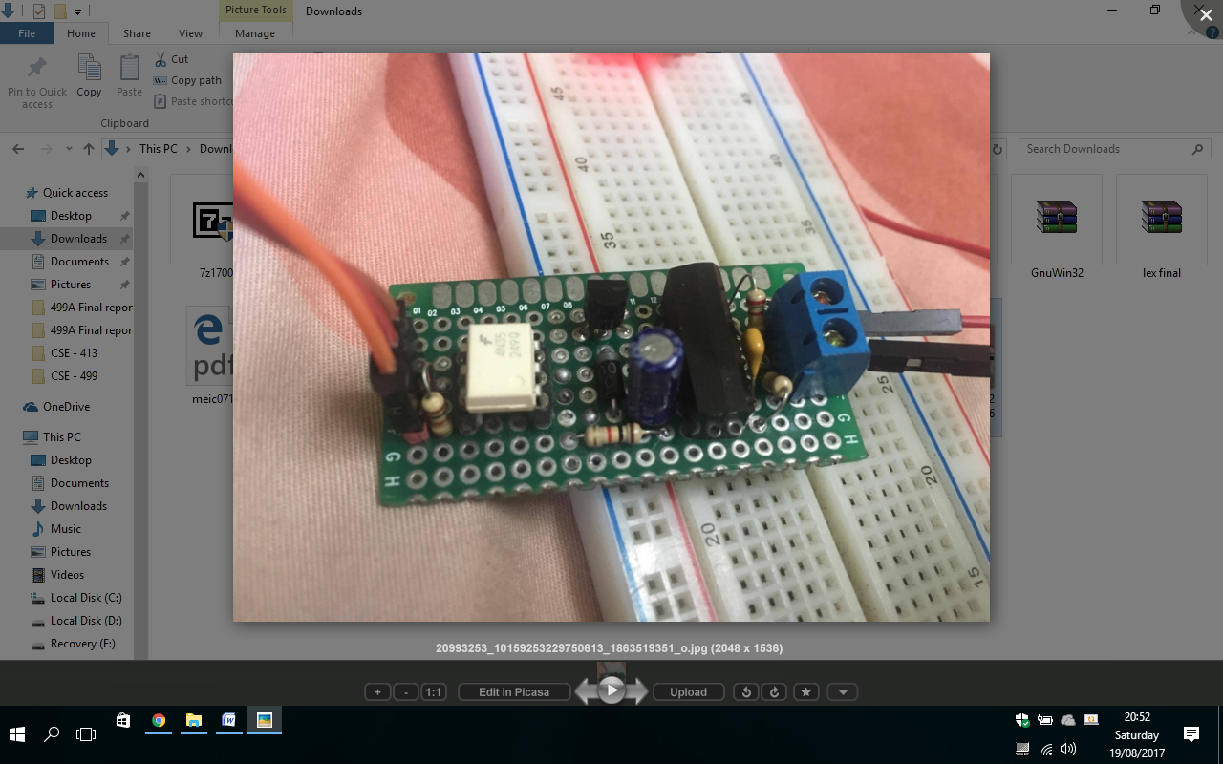

The following circuit produced fairly accurate results and the results are given below:

As seen on an oscilloscope:

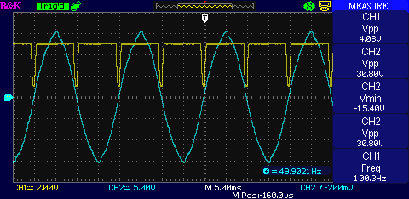

As seen on the Arduino serial monitor:

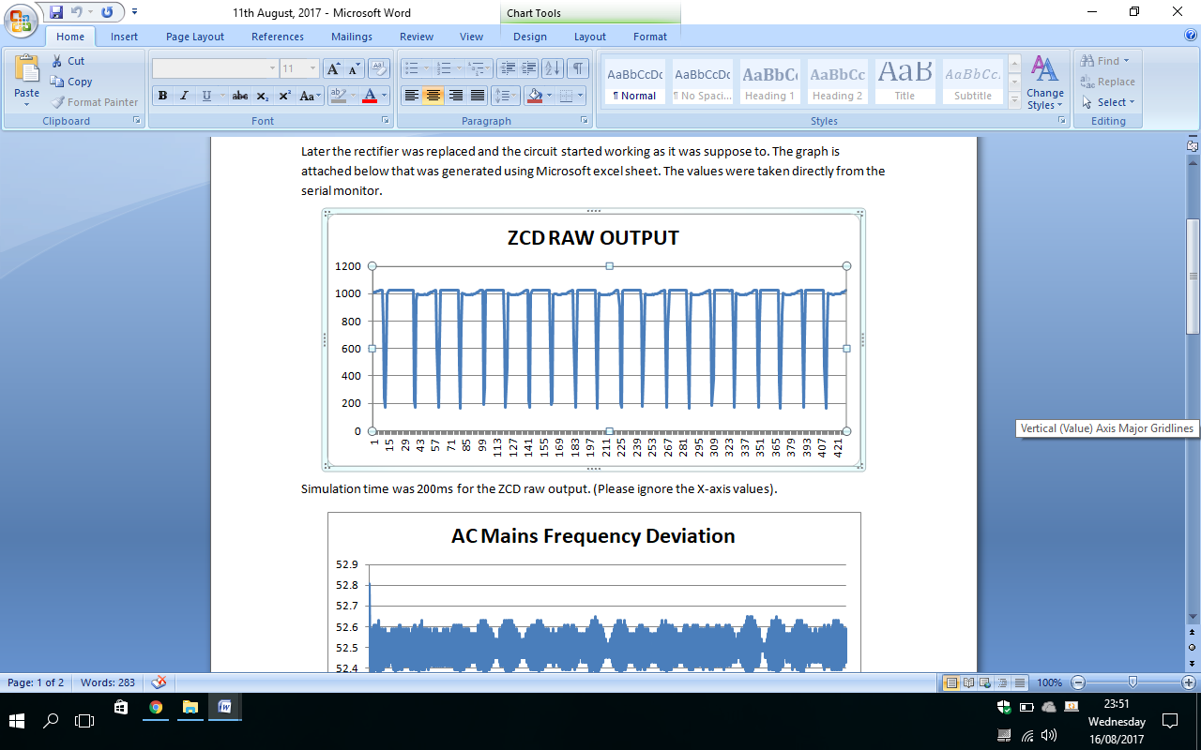

Error calculations:

|  |  |
| --- | --- |
| Mean = | 0.000661 |
| Variance= | 1.74E-09 |
| Standard Deviation= | 4.17E-05 |

A web app was also created with different versions as posted below -

Using simple HTML coding:

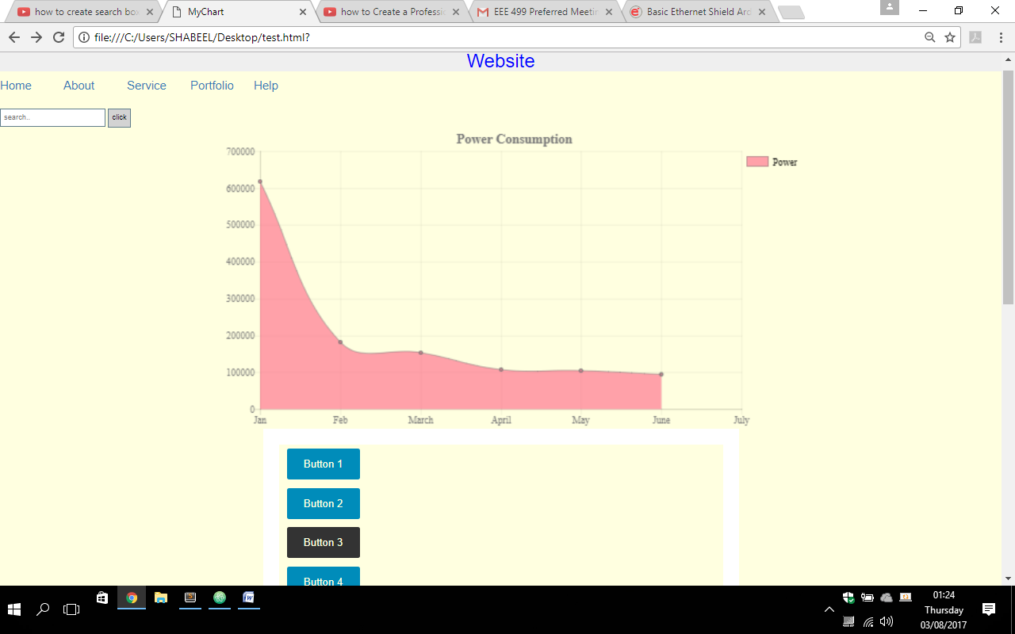

Using Django and REST Framework:

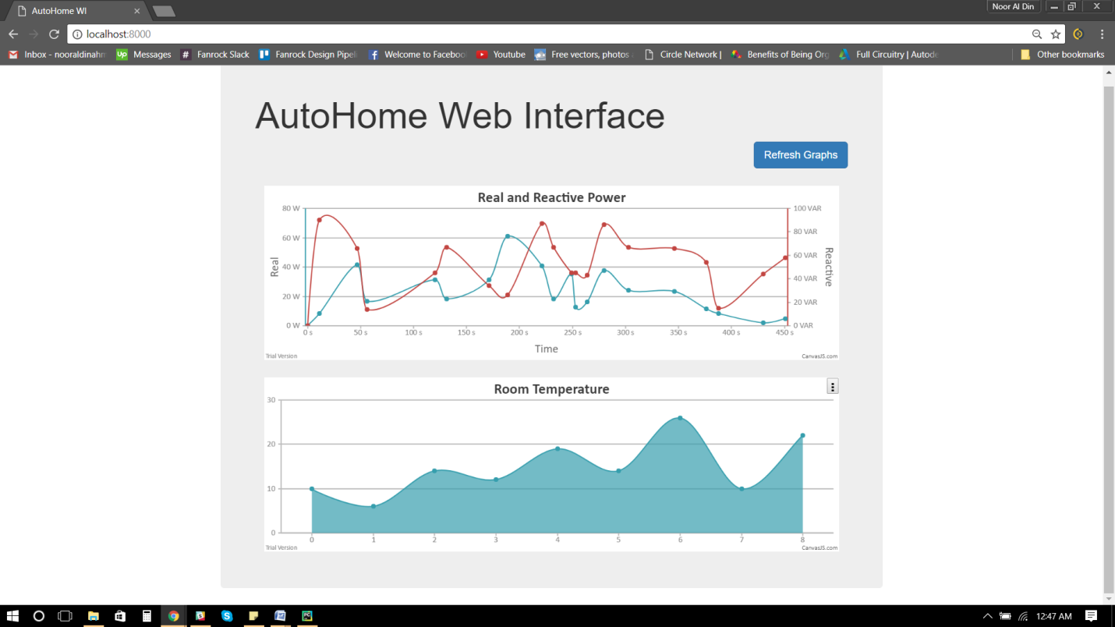

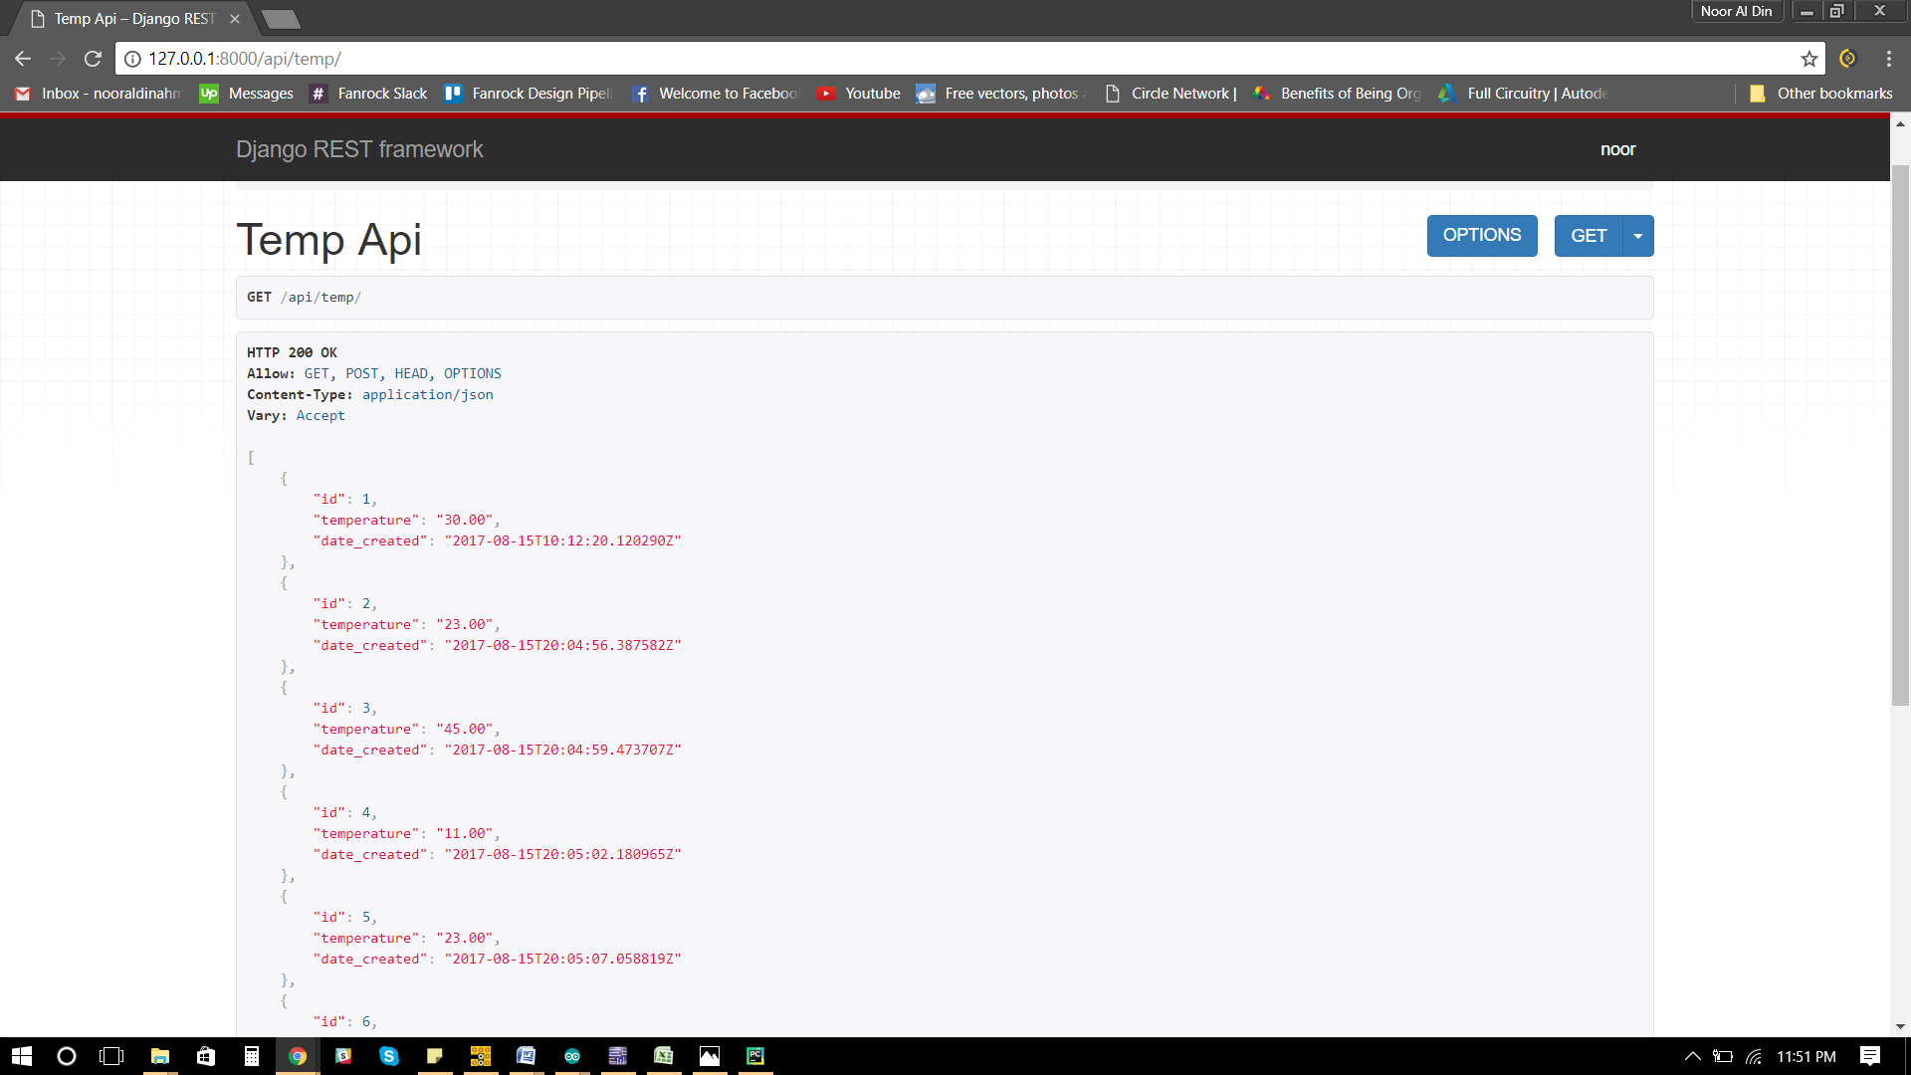

**Summary:**

For the Hardware part:

We have successfully made a Zero-Crossing Detector and implemented it with the arduino and got the desired result with minor drawbacks and errors. For now the Zero-Crossing detector was successful at detecting the frequency of our homes AC mains signal. At first, the detector was not working, but later it was found that the bridge rectifier was faulty. The zero-crossing detection is not always on point but it will get the job done for our project. The standard deviation was 4.17x10-5 and the mean error was 661ms from the point of zero crossing using 9 sample values.

For the software part:

We have successfully built a web application for our project using the Django Framework with API functionalities. Now, we can use the website as a server for our product where it can store and deploy data as needed. It will also show us the data of users activities through graphs that is integrated in the GUI.